String in Switch Case in Java

Java Enums can be thought of as classes which have a fixed set of constants (a variable that does not change). The Java enum constants are static and final implicitly. It is available since JDK 1.5.

- class EnumExample1{
- //defining the enum inside the class
- public enum Season { WINTER, SPRING, SUMMER, FALL }
- //main method
- public static void main(String[] args) {
- //traversing the enum
- for (Season s : Season.values())
- System.out.println(s);
- }}

Output:
WINTER
SPRING
SUMMER
FALL

- class EnumExample1{
- //defining enum within class
- public enum Season { WINTER, SPRING, SUMMER, FALL }
- //creating the main method
- public static void main(String[] args) {
- //printing all enum
- for (Season s : Season.values()){
- System.out.println(s);
- }
- System.out.println("Value of WINTER is: "+Season.valueOf("WINTER"));
- System.out.println("Index of WINTER is: "+Season.valueOf("WINTER").ordinal());
- System.out.println("Index of SUMMER is: "+Season.valueOf("SUMMER").ordinal());

- }}
Output:
WINTER
SPRING
SUMMER
FALL
Value of WINTER is: WINTER
Index of WINTER is: 0
Index of SUMMER is: 2

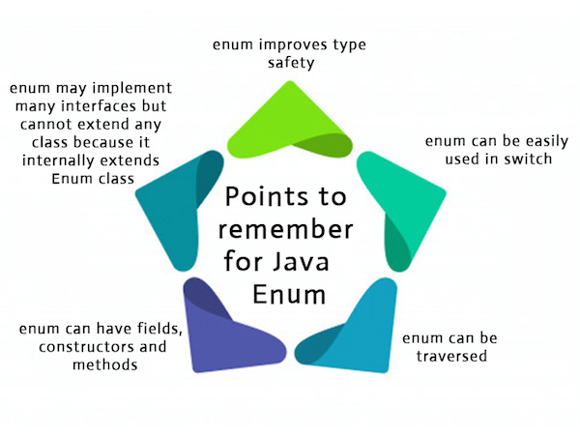

Before JDK 7
Prior to JDK 7, enum could approximate a String-based switch. This uses the static valueOf method generated by the compiler on every enum type.
For example:
Pill p = Pill.valueOf(str);
switch(p) {
case RED: pop(); break;
case BLUE: push(); break;
}

Of course your enumeration could have an entry for 'other', and a fromString(String) method, then you could have
ValueEnum enumval = ValueEnum.fromString(myString);
switch (enumval) {
case MILK: lap(); break;
case WATER: sip(); break;
case OTHER:
default: dance(); break;
}

The following is a complete example using java enum's instead of using a custom method:

public class Main {

public static void main(String[] args) {

String current = args[0];
Days currentDay = Days.valueOf(current.toUpperCase());

switch (currentDay) {
case MONDAY:
case TUESDAY:
case WEDNESDAY:
System.out.println("boring");
break;
case THURSDAY:
System.out.println("getting better");
case FRIDAY:
case SATURDAY:
case SUNDAY:
System.out.println("much better");
break;

}
}

public enum Days {

MONDAY,
TUESDAY,
WEDNESDAY,
THURSDAY,
FRIDAY,
SATURDAY,
SUNDAY
}
}

hashCode()
If you are not using JDK7 or higher, you can use hashCode() to simulate it. Because String.hashCode() usually returns different values for different strings and always returns equal values for equal strings, it is fairly reliableSo, the code would look like this:
String s = "<Your String>";

switch(s.hashCode()) {
case "Hello".hashCode(): break;
case "Goodbye".hashCode(): break;
}
That way, you are technically switching on an int.
But, be careful while using hashCode( ), because Different strings can produce the same hash code, such as "FB" and "Ea") may create same hashCode( ). Better to avoid it.
See documentation.

Strings in switch
Beginning with JDK 7, we can use a string literal/constant to control a switch statement, which is not possible in C/C++. Using a string-based switch is an improvement over using the equivalent sequence of if/else statements.
Yes, we can use a switch statement with Strings in Java. While doing so you need to keep the following points in mind.
- It is recommended to use String values in a switch statement if the data you are dealing with is also Strings.
Important Points:
- Expensive operation: Switching on strings can be more expensive in term of execution than switching on primitive data types. Therefore, it is best to switch on strings only in cases in which the controlling data is already in string form.

- String should not be NULL: Ensure that the expression in any switch statement is not null while working with strings to prevent a NullPointerException from being thrown at run-time.

- Case Sensitive Comparison: The switch statement compares the String object in its expression with the expressions associated with each case label as if it were using the String.equals method; consequently, the comparison of String objects in switch statements is case sensitive.

- Better than if-else: The Java compiler generates generally more efficient bytecode from switch statements that use String objects than from chained if-then-else statements.
Same Program replaced by Strings in Java:
public static void main(String[] args) {

switch (args[0]) {
case "Monday":
case "Tuesday":
case "Wednesday":
System.out.println("boring");
break;
case "Thursday":
System.out.println("getting better");
case "Friday":
case "Saturday":
case "Sunday":
System.out.println("much better");
break;
}

}

String in Switch Statement Example 1
// Java program to demonstrate use of a
// string to control a switch statement.
public class Test
{
public static void main(String[] args)
{
String str = "two";
switch(str)
{
case "one":
System.out.println("one");
break;
case "two":
System.out.println("two");
break;
case "three":
System.out.println("three");
break;
default:
System.out.println("no match");
}
}
}
Output:
two

String in Switch Statement Example 2
public class StringInSwitchStatementExample {
public static void main(String[] args) {
String game = "Cricket";
switch(game){
case "Hockey":
System.out.println("Let's play Hockey");
break;
case "Cricket":
System.out.println("Let's play Cricket");
break;
case "Football":
System.out.println("Let's play Football");
}
}
}
Output:
Let's play Cricket

The switch statement compares the String object in its expression with the expressions associated with each case label as if it were using the String.equals method; consequently, the comparison of String objects in switch statements is case sensitive.

String in Switch Statement Example 3
import java.util.Scanner;
public class SwitchExample {
public static void main(String args[]) {
Scanner sc = new Scanner(System.in);
System.out.println("Available models: Activa125(act125), Activa5G(act5g),"+ " Accesses125(acc125), Vespa(ves), TvsJupiter(jup)");
System.out.println("Select one model: ");
String model = sc.next();
switch (model) {
case "act125":
System.out.println("The price of activa125 is 80000");
break;
case "act5g":
System.out.println("The price of activa5G is 75000");
break;
case "acc125":
System.out.println("The price of access125 is 70000");
break;
case "ves125":
System.out.println("The price of vespa is 90000");
break;
case "jup":
System.out.println("The price of tvsjupiter is 73000");
break;
default:
System.out.println("Model not found");
break;
}
}
}

Output
Available models: Activa125(act125), Activa5G(act5g), Accesses125(acc125), Vespa(ves), TvsJupiter(jup)

Select one model:
act125
The price of activa125 is 80000

